Then Moses went up on the mountain, and the cloud covered the mountain. The glory of the Lord settled on Mount Sinai, and the cloud covered it six days; and on the seventh day He called to Moses out of the midst of the cloud.

Exodus 24:15-16
Click on this word. A box should appear. This box is for the particulars of the congregation, time, address, pastor, etc.
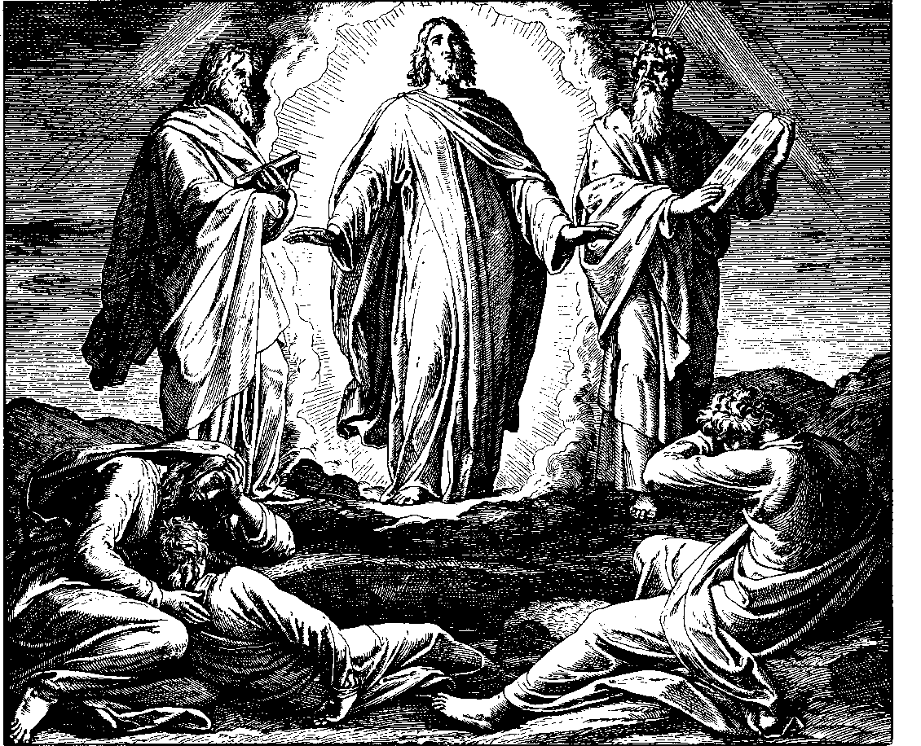
Accordingly, Christ held these three more dear than the others, just as it is clearly recorded by John [chap. 20] that Christ held him more dear than the others. Thus one can also perceive that Christ gave these three special names, Mark 3. To Simon He gave the name of Peter; James and John He called … sons of thunder. Thus we are reminded that a heavy cross is an indication of exceptional divine love – just as a father deals much more sharply with a pious child than with an undutiful servant. David was a man after God’s heart. Even so David stated: You allow me to experience much and great anguish (anxiety), Psa. 71.
Furthermore, Christ took these three, rather than the others, into His suffering because they had viewed His transfiguration upon Mount Tabor, Mat. 17, and His raising of the daughter of Jairus in Mat. 9. Even as they had viewed this glimpse of Christ’s glory, He walso wanted them to behold His outward degradation (humiliation). He wanted to teach that all heartfelt joy of the Spirit in this life is provided by God for this purpose: that one would later on be the better reconciled to suffering. And indeed, the more one grows in a mighty confession and spiritual perception of divine grace and power, the more suffering God takes care to generally lay on [a person]. For God takes pains to deal so graciously with His own that He allows a powerfully sweet taste of His goodness to precede whenever a bitter, strong drink [of anguish and sorrow] is to follow.
An Explanation of the History of the Suffering and Death of our Lord Jesus Christ
by Johann Gerhard
page 60
© 1998 by Elmer Hohle, Published by Repristination Press in 1999
Used with permission.
The Transfiguration of our Lord

10 February Anno Domini 2002

And when they lifted up their eyes,

they saw no one but Jesus only (Matthew 17:8).
The Transfiguration by Julius Schnoor von Carolsfeld.
Permission to use this image is limited to personal and congregational use.
Courtesy of Wisconsin Evangelical Lutheran Synod - the World Mission Collection.

Scripture text is based on Revised Standard Version © 1946, 1952, 1971 Division of Education and Ministry of the National Council of the Churches of Christ in the United States of America.
All Rights Reserved.

This bulletin cover made available by www.scholia.net and is provided without cost.
Then Moses went up on the mountain, and the cloud covered the mountain. The glory of the Lord settled on Mount Sinai, and the cloud covered it six days; and on the seventh day He called to Moses out of the midst of the cloud.

Exodus 24:15-16
Accordingly, Christ held these three more dear than the others, just as it is clearly recorded by John [chap. 20] that Christ held him more dear than the others. Thus one can also perceive that Christ gave these three special names, Mark 3. To Simon He gave the name of Peter; James and John He called … sons of thunder. Thus we are reminded that a heavy cross is an indication of exceptional divine love – just as a father deals much more sharply with a pious child than with an undutiful servant. David was a man after God’s heart. Even so David stated: You allow me to experience much and great anguish (anxiety), Psa. 71.
Furthermore, Christ took these three, rather than the others, into His suffering because they had viewed His transfiguration upon Mount Tabor, Mat. 17, and His raising of the daughter of Jairus in Mat. 9. Even as they had viewed this glimpse of Christ’s glory, He walso wanted them to behold His outward degradation (humiliation). He wanted to teach that all heartfelt joy of the Spirit in this life is provided by God for this purpose: that one would later on be the better reconciled to suffering. And indeed, the more one grows in a mighty confession and spiritual perception of divine grace and power, the more suffering God takes care to generally lay on [a person]. For God takes pains to deal so graciously with His own that He allows a powerfully sweet taste of His goodness to precede whenever a bitter, strong drink [of anguish and sorrow] is to follow.

An Explanation of the History of the Suffering and Death of our Lord Jesus Christ
by Johann Gerhard
page 60
© 1998 by Elmer Hohle, Published by Repristination Press in 1999
Used with permission.
To place the graphic on this page:
Click on the graphic on the previous page and copy it.
Come down to this page. Click on the open space above and a graphic box should appear. Paste the graphic.

Change this frame and the box above by clicking the body of the text, deleting this text (not the box) and adding your particulars.
The Transfiguration of our Lord

10 February Anno Domini 2002
The Transfiguration by Julius Schnoor von Carolsfeld.
Permission to use this image is limited to personal and congregational use.
Courtesy of Wisconsin Evangelical Lutheran Synod - the World Mission Collection.

Scripture text is based on Revised Standard Version © 1946, 1952, 1971 Division of Education and Ministry of the National Council of the Churches of Christ in the United States of America.
All Rights Reserved.

This bulletin cover made available by www.scholia.net and is provided without cost.

And when they lifted up their eyes, they saw no one but Jesus only.

Matthew 17:8

